Digital consulting as done by Vordik
Looking for digiral consulting company that woould suit your needs? Welcome to Vordik, then. We excel at tailored, bespoke digital consultinng services for customers of all types and all verticals from all over the world.

How Vordik does digital consulting
Our approach is user-centric - as is internet today - thus, adjusting best to the demanding envornment, Vordik offers complex and multi-layered core service streams in digital consulting, UX and UI desing, full-stack digital product develpment, as well as product support after the product is finally launched.

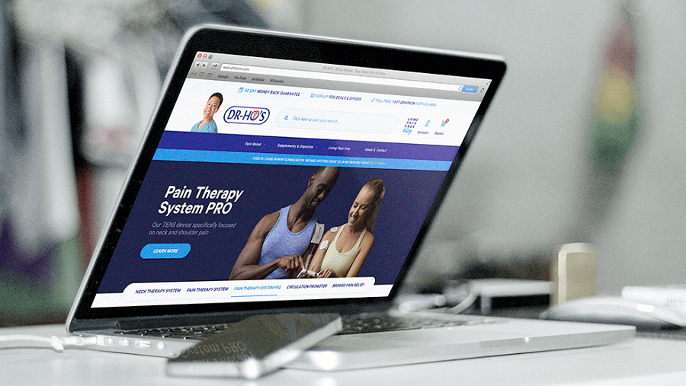
The background
With 7 years of market experience, Vordik can assist any type of customer. Our digital consutling aims at reflecting the multi-faceted nature of the XXI century's digital product user experience. Therefore, Vordik consultancy includes diverse types of strategies: content strategy, web and mobile, as well as cross-platform integrations strategy, too. WE conduct analyses and audits of usability, security and performance of the digital products already existing.
On the basis of this deep understanding, we recommend how to proceed - either with updates or with building a new product - full stack development is also somethng Vordik excels in. After the product is released, Vordik offers complex, holistic support and maintenance services.


More info here: vordik.com

